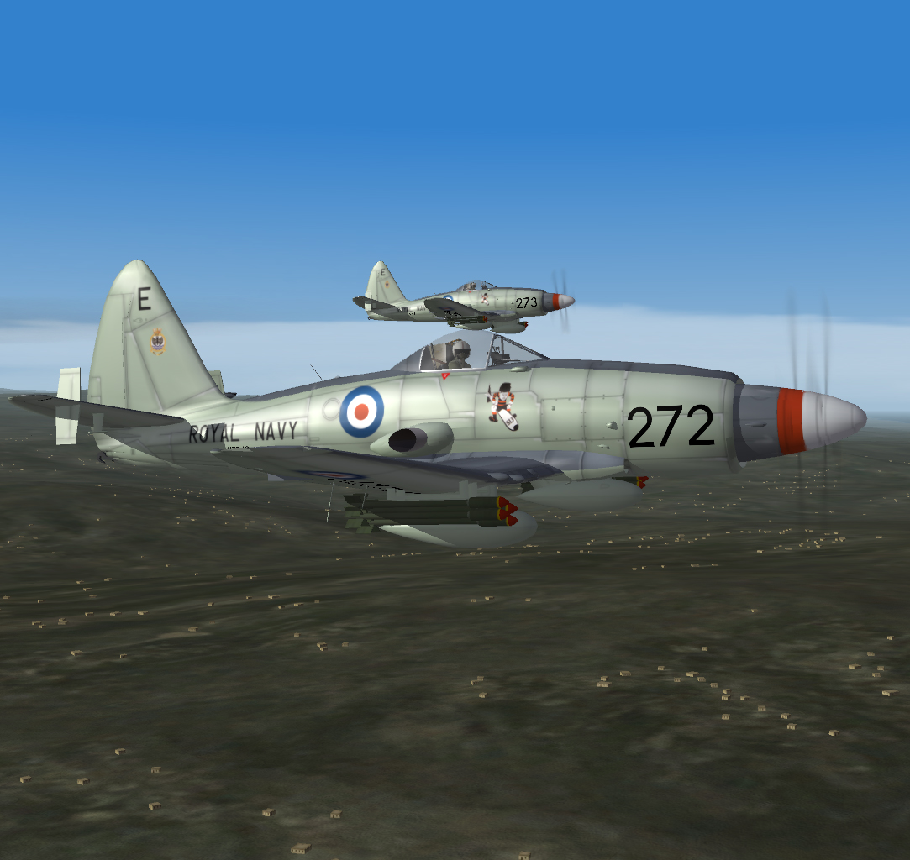
Pilot’s Notes
WYVERN S.4

Wyvern S.4

Introduction

- The Wyvern S.4 is a single-seat Naval strike aircraft powered by a single Python 3 reverse axial flow propeller-turbine engine, driving two four-bladed counter-rotating constant-speed propellers and developing 3605 shaft horsepower plus 1340lb static thrust at sea level.
- Numbers in brackets refer to the illustrations at the end of this document.

Fuel System

- Fuel is carried in three fuselage tanks, two inner wing tanks and two outer wing tanks. Two external tanks may also be carried.
- The capacities of the tanks, in gallons, are:-

Main tank - 67
Fuselage rear tank - 106
Fuselage front tank - 95
Inner wing tanks (2 x 29) - 58
Outer wing tanks (2 x 95) - 190
Total (internal) - 526
Drop tanks (2 x 90) - 180
Total (all tanks) - 706
- When less than 245 gallons remain in the fuselage tank group indicator (39) will illuminate, this is just under 50% internal fuel.
- Three electric fuel contents gauges (34)(37) & (38) indicate the contents of the
Fuselage tank group
Inner wing tanks
Outer wing tanks.

Engine Controls

- The throttle lever gives complete control over the engine and propeller through the fuel control unit and the propeller control unit.
- In the event of complete engine failure the blades will move to the feathered position.
- Fire indicators are located on the starboard panel (35) next to the fire extinguisher controls (36)
- Engine instruments are located on the starboard panel. The fuel distributer pressure gauge (31) is intended for ground fault diagnosis, there is no correlation between fuel pressure and consumption.

Electrical System

- A single 3000-watt engine-driven generator supplies the whole of the electrical system. A failure lamp (26) illuminates whenever the generator is not supplying power.

Aircraft Controls

- The flying controls are conventional. A combined indicator for rudder and aileron trim is located on the port instrument panel (46). The elevator trim is controlled by a hand wheel (3) with trim marking.
- A Radio Altimeter (41) is located on the port instrument panel with the limit setting knob on its left. Warning lamps (19) are to the left of the GGS.
- A Contact Altimeter (43) is to the left of the Radio Altimeter with the associated warning lamp (27) to the right of the GGS.
- The Gyro Gun Sight (GGS) is mounted above the centre of the instrument panel.

Limitations

Maximum all up weights
Take off - 24500lb
All permitted forms of flying - 21200lb
Airfield landing - 20700lb
Deck landing - 18500lb
Note: Gentle manoeuvres only are permitted at all up weights in excess of 21200lb.

Maximum speeds in knots
Clean aircraft - 435 or 0.7M
With external tanks - 435 or 0.7M
Airbrake operation - No Limit post Mod 258 (incorporated)
Flaps at first stage - 305
Flaps at second and third stage - 170
Undercarriage extension - 170
Hood opening - 205

Flying Limitations

- The aircraft is released for universal land or carrier based operation.
- Intentional spinning, all aerobatics (other than barrel rolls at speeds above 250 knots) and the carriage and use of RATOG are prohibited.

Before Take Off Checks

Elevator Trim Set
Airbrakes Closed
Flaps 2 Stages
Instruments Set
Canopy As required
Tailwheel Locked

Once airborne retract the undercarriage and then the flaps, retrimming as necessary.
Recommended climb speed is 165kts from sea level to 10000ft, thereafter reducing by two knots per 1000ft.

Stalling

Approximate stall speed in knots.
 | 18500lb | 19400lb | 21200lb
Power off  Flaps & u/c UP  Flaps & u/c DOWN  Power on  Flaps & u/c Down | 105  90  85 | 110  95  90 | 115  105  95

Checks Before Landing

Brakes Off
Airbrakes Closed
Undercarriage Down and Locked
Tailwheel Lock On, if landing ashore
Flaps 2nd Stage, Fully down on final approach
Fuel Note contents

Approach and Landing

The circuit should be made at 140-150kts. The turn on to final approach should be made at 120-130kts, and the airfield boundary crossed at 105-110kts.
If necessary remove the instrument panel (Numpad .) to improve the landing view.
Deck landing, the recommended speed by day at all weights on the final approach is 105kts.
At low fuel levels it may be necessary to use fuel aft trim to avoid reaching the limits of elevator effectiveness. N.b. this was a ‘feature’ of the real aircraft, the mind boggles.

Shut Down Checks

Run the engine at 60% rpm for 30 seconds.
Close the throttle to the ground idle position and stop the engine by fully closing the Mixture lever.
When the propellers have ceased turning:-
Electrical services Off

Notes on the SF Model

Certain simplifications have been made to the operation of the SF Wyvern. In some cases due to the constraints of the program, in others because either it was more fun or it exceeded the limits of the teams knowledge!
The engine controls were more sophisticated than modelled with the throttle control (and an additional switch) limiting the minimum pitch that could be applied to the prop. This ensured level flight could be maintained in the event of a control unit failure; in SF you essentially have carefree handing of the throttle.
As far as any of the references consulted could reveal the real aircraft didn’t have a landing light, and this seems a common theme of RN aircraft up to and including the Buccaneer.
The API was actually a Doppler fed navigation computer which would require an initial fix. These systems are also prone to drift due to inaccuracies in their operation of the order of more than two miles in a twenty minute period. Due to the lat/long values not being readily available to the cockpit model the functionality of the unit has been reduced to displaying the range to the next waypoint, the other counters reading zero.
The wing fold animation remains from the FSX model and has been assigned to animation group 8. The version modelled does not feature the folding wingtips. These were only a feature of the early production Wyvern (VZ791 and prior) and were unpopular with the aircrew as the tips were ideally positioned to hit their heads on leaving the aircraft. As post war carrier hangars were higher than those the Wyvern was originally designed for they were deleted, additionally as the outer sections were manually folded it was possible for the early aircraft to dispense with folding them.
Unfortunately the only surviving Wyvern is a TF.1 Eagle engined prototype which has a number of detail differences from the production S.4 aircraft. To this end we had to make some guesses as to what some items did and or where they were located or what colour they were. If anyone has more accurate information we’d love to hear about it, and if it doesn’t threaten what’s left of our sanity we might include it in an update.
External stores. The default load outs for the Wyvern utilise the UK 500lb bomb and the 60lb rocket. Depending on which simulator you install the aircraft in you may need to add these weapons manually, for further information see here. In addition the Wyvern features custom drop tanks. These have been incorporated in to the aircraft model, but the following entry needs to be added to the WeaponsData.ini to activate them, in accordance with the instructions at the above link.
[WeaponDataXXX]
TypeName=WyvernTank
FullName=90-gal Drop Tank
ModelName=
Mass=340.500000
Diameter=0.529000
Length=2.340000
SubsonicDragCoeff=0.060000
SupersonicDragCoeff=0.605000
AttachmentType=
SpecificStationCode=
NationName=
StartYear=0
EndYear=0
Availability=0
BaseQuantity=0
Exported=FALSE
ExportStartYear=0
ExportEndYear=0
ExportAvailability=0
WeaponDataType=5
MaxFuelAmount=332.100006
Asymmetrical=FALSE

I can’t see over the nose, no neither can I. You could alter the viewpoint, however you’ll then find your head inside the D handle for the ejector seat. If you look at the geometry of the model you’ll realise the Wyvern had appalling forward visibility, that’s why Westlands raised the cockpit up on a hump in a desperate attempt to improve it.

We hope you enjoy the Wyvern for SF and take some time to remember that of the 90 S.4 built 68 had accidents and 39 were lost including 13 fatalities and 14 ejections. For more information we’d like to recommend ‘Wyvern’ From the Cockpit by Michael J. Doust and published by Ad-Hoc Publications. Amazon are probably a good bet, they sell most things.
Comments, Information and offers of beer to p.chandler@btinternet.com, subject:Wyvern or we normally hang around the forums at www.cbfsim.org and http://forum.combatace.com/

Credits
Due to the frankly ridiculous gestation time of this project a large number of people were in some way involved. For providing the initial cutaways and other technical resources Richard Harris and Andrew Goodair were invaluable, even if they’ve probably forgotten they ever sent me anything! The posters at the Free Flight Design Forums, Combatace and Classic British Flight Sim all provided inspiration, advice and information throughout the two and a half years and three sims that the Wyvern has been going.
Richard Ruscoe - The Flight Model
Fraser Paterson - Graphics
Philip Chandler - Models, SF Conversion
Ian Kirby - FSX Alpha, Beta and possibly Gamma testing
Mark Barber - FSX Beta Testing
Steve Beeny - Web Guru
Dave - SF Beta Testing
Triplethr3at - SF Beta Testing
Dreamstar - SF Beta Testing
JA 37 Viggen - SF Beta Testing
Dwcace - SF Beta Testing

Note the following illustrations are from the FSX version of the aircraft hence not all features will be available in SF. However it was felt the extra information may be of interest and inspire you to download the FSX version as well.

FIG 1 – COCKPIT PORT SIDE

- Tail Wheel Lock
- Arrestor Hook Switch
- Pitch Trim
- Mixture
- Throttle
- Fuel Tank Selector (Off – All – Centre – External)
- Air Position Indicator (Lat/Long and True Heading)
- Dive Brake
- OAT
- Emergency Flap Extension
- Normal Flap Extension

FIG 2 – COCKPIT FORWARD VIEW

- Flap Position Indicator
- Arrestor Hook Deployed Light
- Gear Indicator
- Undercarriage Switch
- Mach Meter
- Pressure Altimeter
- ASI
- RAD ALT Warning Lamps
- Gyro Gun Sight Retraction Switch
- Gyro Compass
- Attitude Indicator
- Turn and Slip Indicator
- RCDI (Rate of Climb and Descent Indicator)
- GGS Emergency Retraction
- Generator Warning Lamp
- Contact Altimeter Warning Lamp
- RPM Gauge
- Torque Gauge
- Reverse Torque Warning Lamp
- Fuel Pressure
- Exhaust Gas Temperature
- Oil Temperature
- Fuselage Fuel Tank Contents
- Fire Warning Lamps
- Fire Extinguisher Switches (Guarded)
- Inner Wing Fuel Tank Contents
- Outer Wing Fuel Tank Contents
- Low Fuel Lamp (245 Gallons Remaining)
- Oil Pressure Gauge
- Radar Altimeter
- Starter Switch (Guarded)
- Contact Altimeter
- Igniters Warning Lamp
- Ignition Switch
- Trim Indicators

FIG 3 – COCKPIT STARBOARD SIDE

- Wing Pylon State
- Fuselage Pylon State
- Navigation Lights
- Strobe Light
- Landing Light
- Canopy
- Cockpit Lighting
- Battery
- Avionics
- Generator
- Master Armament

